
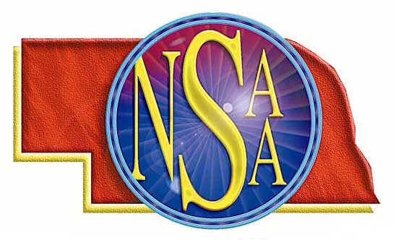
Misconduct
Penalty Chart
 | Player | Bench Personnel | Coach
Yellow Card | - Must leave field until next legal substitution opportunity  - May be substituted or play short | - Substitute (nonplayer) remains in team area until next legal substitution opportunity  - Other bench personnel remain in team area | - Remains in team area
Yellow/Red Card  (soft red) | - Must leave field  - May not return  - May be substituted or play short  - Restricted to team area  - File NSAA online ejection report | - Not applicable | - Not applicable
Red Card | - Must leave field  - May not return  - May not be substituted; MUST play short  - Restricted to team area  - File NSAA online ejection report | - Restricted to team area for substitutes or other students  - Adult bench personnel MUST leave vicinity of playing area  - File NSAA online ejection report | - MUST leave the vicinity of playing area  - File NSAA online ejection report

